# Machine Learning Application for Cosmetics Shop

## 1) Problem Statement

Apply an appropriate ML algorithm on a dataset collected in a cosmetics shop showing details of customers to predict customer response for special offers.

## 2) Libraries Used

Python:  
Pandas: For data manipulation and preprocessing.  
NumPy: For numerical operations and array manipulation.  
Scikit-learn: For machine learning algorithms and model evaluation.  
Matplotlib: For data visualization.  
Seaborn: For enhanced data visualization.

## 3) Theory

The theory section discusses the application of supervised learning models, specifically logistic regression, to predict categorical outcomes based on historical customer data. The importance of feature selection, data normalization, and the use of performance metrics to evaluate the model are emphasized.

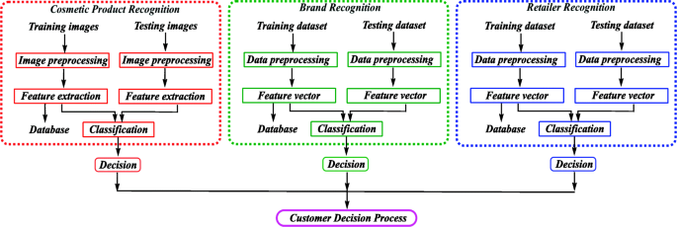

## 4) Methods

The methods section details the data preprocessing steps, the selection of a logistic regression model, training the model on the processed data, and evaluating it using accuracy, precision, recall, and F1-score.

## 5) Advantages

Advantages of using logistic regression in this context include:

* • Simplicity and interpretability of the model.
* • Effectiveness in binary classification tasks.
* • Low variance, reducing the risk of overfitting.

## 6) Disadvantages

Disadvantages of logistic regression include:

* • Assumes linearity between the dependent variable and the independent variables.
* • Performance can degrade with non-linear relationships unless feature engineering is applied.
* • Not flexible enough to naturally capture more complex relationships.

## 7) Working

The working section outlines the step-by-step process of data handling, model application, and iterative refinement, focusing on adapting the logistic regression model to the characteristics of the dataset.

## 8) Conclusion

Conclusively, applying logistic regression to predict customer responses has shown potential for enhancing targeted marketing strategies. However, careful consideration of the model's limitations and proper preprocessing are crucial for achieving accurate predictions.